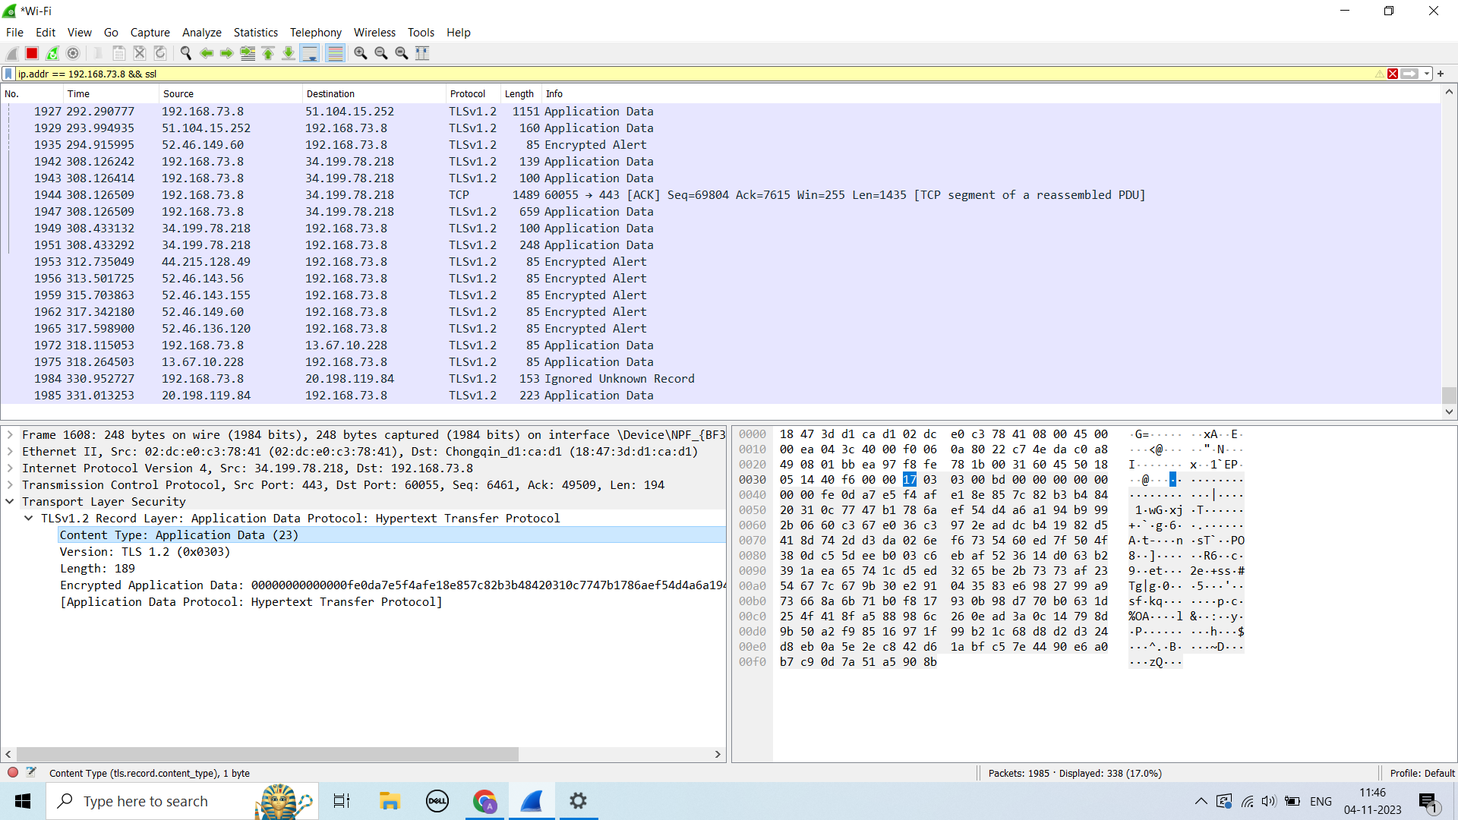

Simply go to the amazon.com and either be on the home page or sign up page where https is used.

And then simply monitor the traffic on the wireshark.